EDSGN 100H

Terrible design

Garrick Jordan

I selected the steering wheel and dashboard of most cars as my poorly designed object. These pieces of a car are intended to allow you to steer and monitor any gauges, mostly the speedometer, by looking through a hole in the top of the steering wheel. For many or even most people this works without any problem, but in the majority of cars when I sit down to drive the top of the steering wheel obscures the top of the speedometer (Fig. 1) and often other gauges as well.

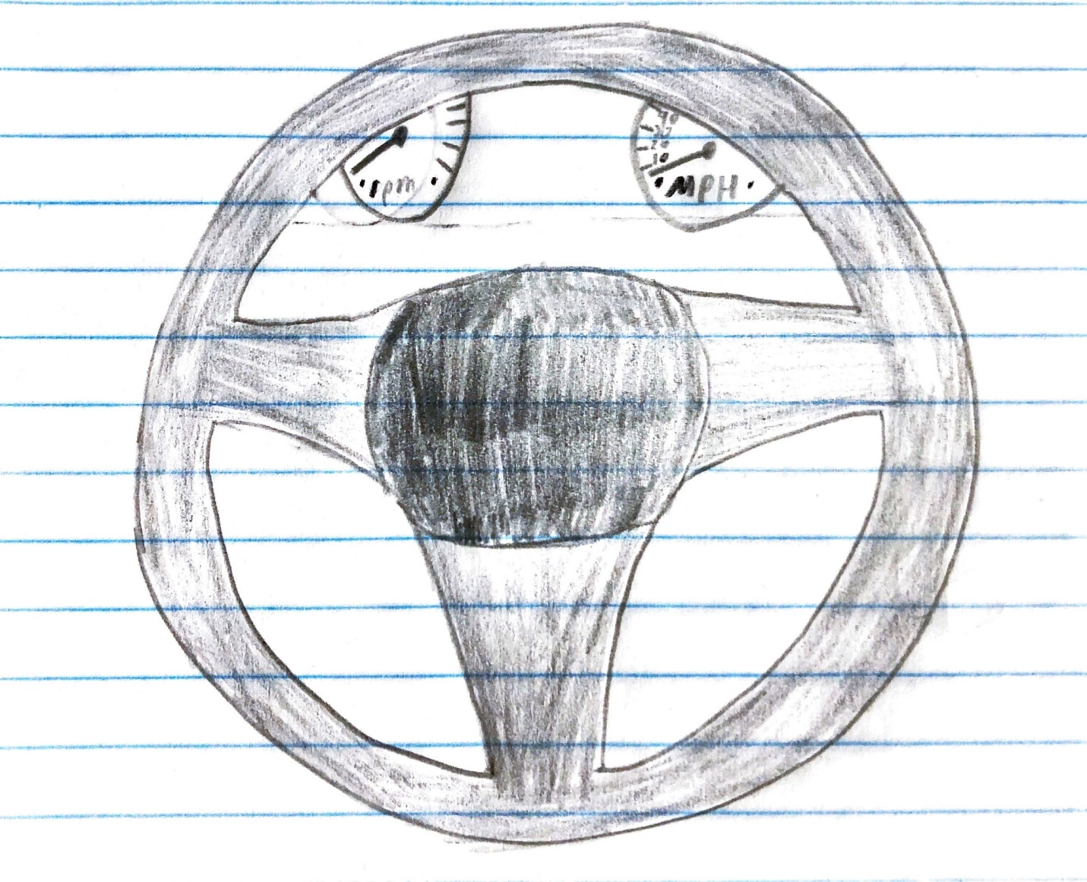

Figure 1. This is a sketch of what I see when I sit down to drive most cars.

This is a problem because it forces me to take my attention off the road to monitor my speed, making driving less safe for both me and the people around me. The designers failed to take into consideration the effects of different heights and proportions of the people that would be driving the cars they designed.

There are many potential solutions for this issue, and the best solution will vary from vehicle to vehicle. Many cars already have already allow for adjustment of the angle of the steering wheel, in theory the upper limit of the angle could be increased, solving the problem. Another solution would be a different steering wheel shape, possibly one with a larger gap to look through or a more rectangular steering wheel that did away with the gap and left the gauges on the dash completely unobscured. There is also the option of moving the gauges to a different location or resizing them to allow for an increased maximum viewing angle. A digital speedometer that could be moved around the screen or even projected onto the windshield as a heads up display.